1.Write a c program to perform matrix multiplication

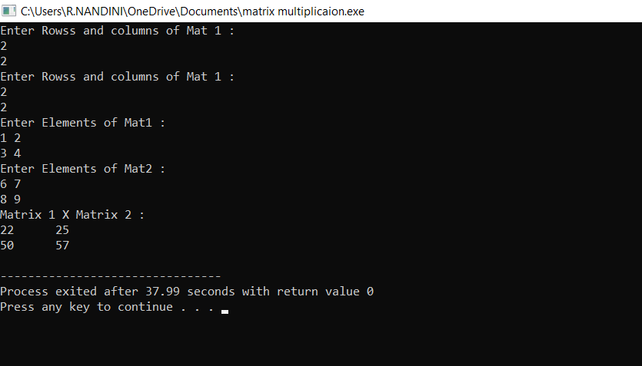

2.Write a c program to find odd or even number from a given set of numbers

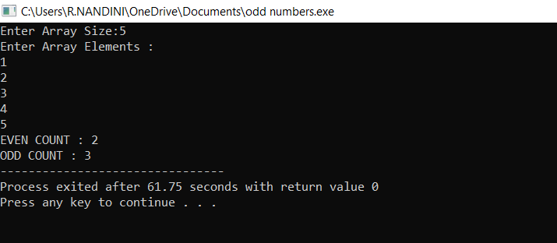

3.Write a c program to find factorial of a given number with out using recursion

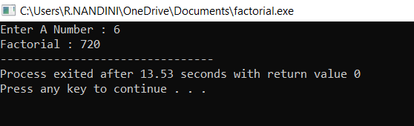

4.Write a c program to find Fibonacci series with out recursion

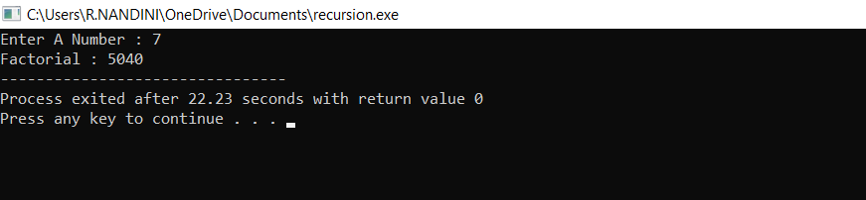

5.Write a c program to find factorial of a given number using recursion

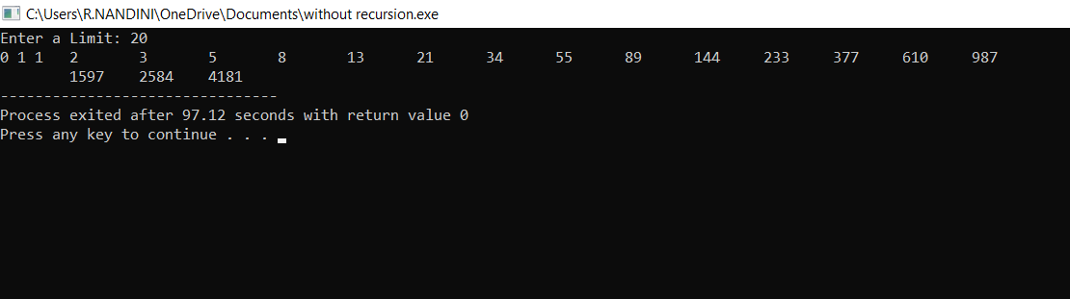

6.Write a c program to find to find Fibonacci series using recursion

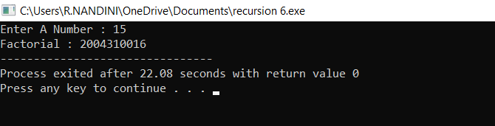

8.write a c program to search a number using linear search method

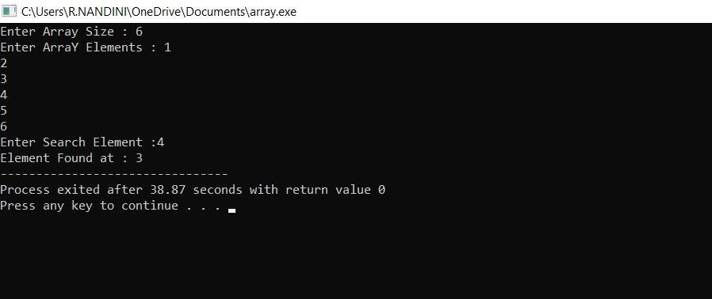

9.Write a c program to search a number using binary search method

